The 14th Southgate Scout Group
Premises Hire Agreement

- Definitions
  - “The Premises” means 14th Southgate Scout Hut (also known as ‘Vincent Fleming Scout Centre’), Green Road, Southgate N14 4AP, and is limited to the main scout hut building, its kitchen and toilets, as well as the grass area, as more fully defined in this agreement (see clause 4 below).
  - “The Hirer” means an individual or organisation entering into an agreement under the terms set out below to license the premises.
  - “The Scout Group” means the 14th Southgate Scout Group.
  - “Booking” means a contract between the Hirer and the Scout Group.
  - “Hire Period” means the Period from the beginning to the end of the hire reserved by the Hirer.
  - “Function” means an event (whether ‘one off’ or recurring) for which the premises are booked.

- Agreement
  - The Scout Group permits the Hirer to use the premises for the function and for the Hire Period described on a booking form completed for that purpose (“the booking form”).
  - The Scout Group warrants that it is entitled to enter into this agreement.
  - The Hirer agrees that it will only use the premises for the function described on the booking form, save with the express written agreement of an authorised representative of the Scout Group.
  - The Hirer agrees to pay an agreed fee for hiring the premises for the Hire Period, which shall be set out on the booking form.
  - The Hirer and the Scout Group agree that nothing in this agreement is intended to create a lease or tenancy, to grant the Hirer exclusive occupation for a term, or otherwise to grant rights to the Hirer as a licensee beyond those set out in this agreement.
  - This benefit/obligations of this agreement may not be assigned by the Hirer, and the Hirer is not permitted to sub-licence the premises.

- Supervision
  - During the Hire Period, the Hirer accepts responsibility for being in charge of and present at the Premises, subject to its right to agree to begin the Hire Period late or end it early by an agreed provision of the keys to the premises.
  - The Hirer shall nominate an individual who shall be present during the Hire Period and act as the Hirer’s principal point of contact during that time, and shall provide the name and contact details of that individual on the booking form. In the event of a prolonged function/Hire Period, successive contacts may be nominated as the Hirer’s principal contact provided the nominees’ contact details are provided and details given to the Scout Group of the periods to which each nominee acts as principal contact.

- Further definition of and access to the Premises
  - The Premises to which this licence pertains are limited to the Vin Fleming Scout Hut hall, the adjacent vestibule, kitchen and toilets, along with the outside grassy area (“the permitted area”). The permitted area is shown in green on the following plan, and excludes that part of the plan shown in red.

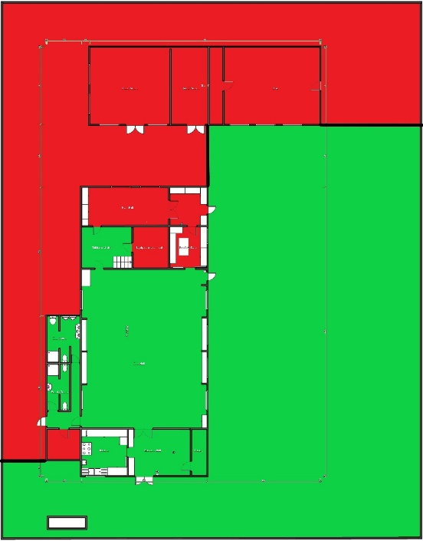
  - For the avoidance of doubt, the permitted area does not include either the Scouts’ office or the outbuildings at the rear (North) of the site.
  - The Premises may be accessed by the locked gates on Green Road, and the Scout Group will make provision to provide keys or open the gates as agreed in each case.
  - The Hirer is permitted to park no more than two vehicles on the concrete area between the gates and the main entrance to the Premises, but shall in no circumstances drive or park on the grass area or anywhere other than that concrete area.
  - The maximum number of attendees at a function in the main hall of the Premises is 150 and, for reasons of safety and insurance, the Hirer agrees that it will not permit any more than 150 persons into the buildings at the Premises at any one time.

- Alcohol, Smoking and Controlled Substances
  - Smoking is not permitted on any part of the Premises (including the outside areas) under any circumstances.
  - The Scout Group does not hold a licence for the sale of alcohol at the Premises. However the Hirer is entitled to apply for a licence for the function, provided that it seeks the prior consent of the Scout Group (such consent not to be unreasonably withheld).
  - Controlled substances such as illegal drugs of any nature are not permitted on any part of the premises at any time and breach of this provision will result in the immediate termination of this agreement, with no refund permitted.

- Animals
  - Animals, except guide dogs, are not permitted at the Premises save with the prior agreement of the Scout Group (such consent not to be unreasonably withheld).
  - Animals are not permitted to enter the kitchen in any event.

- Fire Safety
  - The Hirer agrees to observe all fire precautions during the Hire Period, and shall not obstruct any door or emergency exit.
  - The Hirer agrees not to bring any LPG appliances or flammable substances on to the premises.
  - The Hirer further agrees to notify the Scout Group should there be any outbreak of fire, or should it observe anything of concern with regard to the safety of the premises (such as the smell of gas).

- Noise
  - Green Road is a residential area, and the Hirer should at all times be mindful and respectful of the occupants of neighbouring properties.
  - The Scout Group does not hold a PPL or PRS license for the performance or reproduction of music, nor any television licence, however the Hirer is entitled to apply for an ad hoc licence for the Hire Period with the prior agreement of the Scout Group (such consent not to be unreasonably withheld).
  - The Hirer agrees to avoid excessive noise at all times and in particular to ensure that there is no noise audible beyond the premises after 11.00pm (should the Hire Period extend to this time), and that at any time visitors to the Premises leave the Premises quietly and with consideration to the occupants of neighbouring properties.

- At the end of the Hire Period
  - The Hirer shall ensure that the floors are swept and kitchen and toilets are left clean and tidy. Oil and grease must not be poured into the sink or drains under any circumstances. All kitchen appliances (except the fridge and freezer) must be switched off. Taps in the kitchen and toilets should be turned off, and toilets flushed and left clean. The Scout Group’s kitchenware and crockery stored in the kitchen may be used by the Hirer for the function with the Scout Group’s prior agreement, but must be returned, clean, at the end of the Hire Period to where such items are stored.
  - Any chairs or tables which have been used must be folded where appropriate and returned to where they are stored. Lights should be switched off, and where door or windows have been unlocked by the Hirer during the Hire Period, they should be locked.
  - The Scout Group does not have provision for the regular collection of waste, so the Hirer must remove all rubbish from the premises and dispose of it appropriately. Under no circumstances should the bins belonging to neighbouring properties be used for this purpose.

- Accidents and Damage
  - The Hirer must report any accident or damage to the Scout Group at the end of the Hire Period, or immediately where it is sufficiently urgent to do so, and agrees to pay for any accidental damage or loss to the premises, its fixtures and fittings.
  - Any property brought on to the Premises (and the site more generally) shall remain the responsibility of the Hirer.
  - The Scout Group will ensure that a First Aid kit is made available during the Hire Period which the Hirer shall be entitled to use for attendees at the function, and the Hirer shall familiarise itself with the location and contents of the First Aid kit.
  - The Scout Group holds public liability insurance, however it is the Hirer’s responsibility to ensure that it is appropriately insured for the function during the Hire Period.
  - The Hirer agrees to fully indemnify the Scout Group against any claims, demands, actions or proceedings arising out of this agreement, and in respect of any loss or injury caused to any person coming on to the premises for the purposes of attending the function.

- Payment and Cancellation Policy
  - The parties will agree a fee for the licensing of the premises under this agreement (“the licence fee”), and a deposit upon whose payment (and not before) the booking will be secured. This is noted on the booking form and forms part of the agreement between the Scout Group and the Hirer.
  - The balance of the licence fee shall be paid by the Hirer to the Scout Group no late than 14 days before the Hire Period, and may be transferred to the Scout Group electronically at the following account:

Bank: Lloyd’s Bank plc
Sort Code: 309089
Account No: 38496160

  - Bookings may be cancelled by notifying the Scout Group, and the licence fee will be refundable less a cancellation fee of 20 % of the booking fee.

